Fall 2024 MSE 760 Lab1 Assignment Report

University of Wisconsin-Madison

Electronic Structure and Lattice Constant of Face-Centered Cubic (FCC) Diamond

Jiahui Yang

October 08, 2024

**Abstract**

This report details the computational analysis of the face-centered cubic diamond structure, with a focus on the electronic structure and optimization of the lattice constant. Utilizing norm-conserving pseudopotentials and the Quantum ESPRESSO software, systematic studies were conducted to determine total energy convergence with respect to k-point density and wavefunction cutoff. The lattice constant was optimized by fitting the total energy calculations to the Murnaghan equation of state. Comparative analyses were performed against experimental lattice constants and electronic band structures to benchmark the accuracy of the computational methods. Moreover, the band structure and density of states for diamond were computed and analyzed, providing insights into the directness and size of the band gap. These findings contribute to a deeper understanding of diamond’s electronic properties, with implications for both theoretical and practical applications.

Link to Lab1 Assignment GitHub repo:

<https://github.com/jhyang13/UWMadison_MSE760/tree/main/Lab1-Assignment>

**Contents**

1. Abstract--------------------------------------------------------------------------------------------2

2. Introduction and Methods-----------------------------------------------------------------------4

3. Results and Discussions-------------------------------------------------------------------------

4. Conclusions--------------------------------------------------------------------------------------

5. References-----------------------------------------------------------------------------------------

**General information**

1. Name: Jiahui Yang
2. Email: [jyang753@wisc.edu](mailto:jyang753@wisc.edu)
3. Home Department: Mechanical Engineering
4. Status: PhD Student

**Introduction and Methods**

This report investigates the electronic structure and lattice constant of diamond, a material with a well-known face-centered cubic (fcc) crystal structure and an indirect band gap, making it ideal for computational studies. Using first-principles calculations based on density functional theory (DFT), the study aims to provide insight into the material's properties. The Quantum ESPRESSO software was utilized to perform the calculations with norm-conserving pseudopotentials and the Perdew-Burke-Ernzerhof (PBE) exchange-correlation functional.

The objectives of the study include building the diamond structure with an experimental lattice constant of 3.567 Å, converging the total energy with respect to k-point density and wavefunction cutoff, optimizing the lattice constant by fitting the total energy to the Murnaghan equation of state, computing the band structure, and comparing it with experimental results to determine the band gap. Additionally, the density of states (DOS) was calculated to analyze the electronic structure of diamond in more detail.

SCF calculations were performed with varying k-points and wavefunction cutoffs to ensure accurate convergence. The k-point grid was varied from 2x2x2 to 12x12x12, and the wavefunction cutoff was tested from 20 Ry to 80 Ry. The lattice constant was optimized by fitting the calculated total energies to the Murnaghan equation of state, after which the band structure and DOS were computed using a high-symmetry k-point path through the Brillouin zone.

**Results and Discussions**

1. **Build the structure of diamond (similar to silicon, only different lattice constant)**

Both diamond and silicon have a face-centered cubic structure with a two-atom basis per unit cell. However, the lattice constants for these two materials differ: diamond has an experimental lattice constant of 3.567 Å, while silicon's experimental lattice constant is 5.431 Å.

Though their atomic arrangements are nearly identical, the lattice constant must be adjusted to reflect the smaller atomic spacing in diamond. The diamond structure can be described as a face-centered cubic Bravais lattice with two carbon atoms per unit cell. The carbon atoms are located at fractional coordinates C(0.00, 0.00, 0.00) and C(0.25, 0.25, 0.25) relative to the unit cell. The crystal structure remains the same as silicon, but the smaller lattice constant for diamond results in closer atomic spacing and higher bond strength. This difference significantly impacts physical properties such as hardness, electronic band structure, and thermal conductivity.

In Quantum ESPRESSO simulations, the lattice constant is expressed in atomic units (a.u.), where 1 a.u. = 0.529177 Å. For diamond, the lattice constant in atomic units is:



The diamond structure is simulated in Quantum ESPRESSO by defining the crystal structure, atomic positions, and relevant calculation parameters. Below is the input file (scf.in) for a self-consistent field (SCF) calculation:

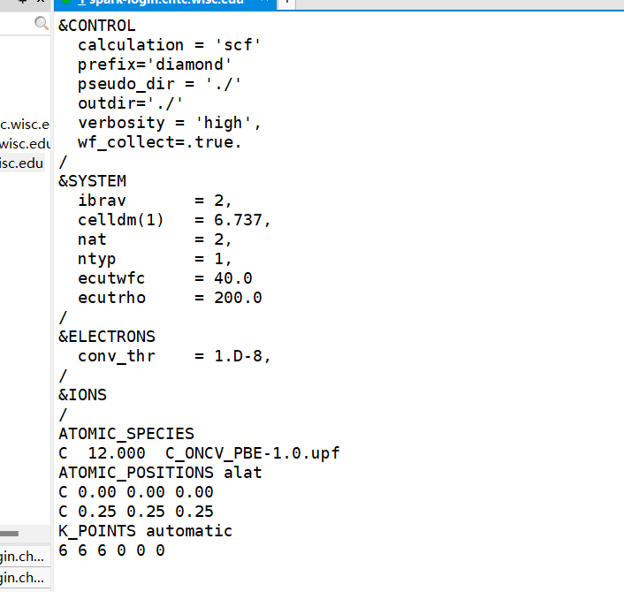

Explanation of Input Parameters:

* **ibrav = 2:** This specifies the face-centered cubic structure.
* **celldm(1) = 6.737:** Defines the lattice constant in atomic units (6.737 a.u.), which corresponds to 3.567 Å in real space, the experimental lattice constant of diamond.
* **nat = 2:** Indicates there are two atoms per unit cell.
* **ntyp = 1:** Specifies that there is only one type of atom in this system, which is carbon.
* **ecutwfc = 40.0:** This defines the cutoff energy for the wavefunctions, a typical value for density functional theory (DFT) calculations using pseudopotentials.
* **ATOMIC_POSITIONS alat:** This defines the positions of the two carbon atoms in the unit cell, where the fractional coordinates (0.00, 0.00, 0.00) and (0.25, 0.25, 0.25) represent the standard diamond structure.
* **K_POINTS {automatic}:** Specifies the k-point grid for sampling the Brillouin zone. The 6x6x6 grid is commonly used for well-converged total energy calculations, providing a good balance between accuracy and computational cost.

1. **Total energy convergence as a function of k-point**

To analyze the total energy convergence as a function of the k-point grid, a series of SCF calculations were performed using Quantum ESPRESSO for the diamond structure. The objective was to determine how the total energy stabilizes as the k-point grid becomes denser, which is crucial for ensuring both accuracy and computational efficiency. The k-point grid was varied across several values: 2x2x2, 4x4x4, 6x6x6, 8x8x8, 10x10x10, and 12x12x12. These grids sample the Brillouin zone with increasing density, capturing more detailed electronic information. For each k-point grid, an SCF calculation was performed using the same input parameters for the diamond structure. The key parameters used in the calculations were as follows: ibrav = 2 (face-centered cubic structure for diamond), celldm(1) = 6.737 (lattice constant corresponding to 3.567 Å), nat = 2 (two carbon atoms per unit cell), ecutwfc = 40.0 Ry (wavefunction cutoff energy), and ecutrho = 200.0 Ry (charge density cutoff energy). After each calculation, the total energy was extracted from the output file. The total energy value, typically found after the SCF cycle has converged, was recorded. The energy is expressed in Rydbergs (Ry).

The table below summarizes the total energy values as a function of the k-point grid size:

|  |  |
| --- | --- |
| **K-point Grid** | **Total Energy (Ry)** |
| 2x2x2 | -22.48872467 |
| 4x4x4 | -22.71537462 |
| 6x6x6 | -22.72504724 |
| 8x8x8 | -22.72624239 |
| 10x10x10 | -22.72572244 |
| 12x12x12 | -22.72603218 |

The total energy values obtained for different k-point grids show that as the k-point grid density increases, the total energy gradually converges. From the initial 2x2x2 grid to the 4x4x4 grid, there is a significant decrease in the total energy, indicating that the 2x2x2 grid is too sparse for an accurate calculation. As the grid becomes denser from 6x6x6 to 12x12x12, the changes in total energy become minimal. The difference in total energy between the 6x6x6 grid and the 8x8x8 grid is only 0.0012 Ry, while the total energy difference between the 10x10x10 and 12x12x12 grids is negligible, at approximately 0.0003 Ry. This suggests that by the **8x8x8 grid**, the total energy has nearly converged, and further increasing the k-point density results in diminishing returns in terms of energy accuracy.

1. **Total energy convergence as a function of wavefunction cutoff**

The wavefunction cutoff energy (ecutwfc) was varied across several values: 20 Ry, 30 Ry, 40 Ry, 50 Ry, and 60 Ry. These values were selected to observe how the total energy stabilizes as the cutoff energy increases, capturing the convergence behavior of the system. For each ecutwfc value, a SCF calculation was performed using Quantum ESPRESSO with the same input parameters, except for the variable cutoff energy. The charge density cutoff energy (ecutrho) was fixed at 200 Ry across all calculations. For each SCF calculation, the total energy was extracted from the output file (scf.out). The total energy values were recorded in Rydberg units (Ry) after the SCF cycle converged. The total energies for each ecutwfc value were compared to determine the cutoff energy at which the total energy converges, indicating that further increases in ecutwfc provide minimal improvements in accuracy.

The table below summarizes the total energy values for the diamond structure as a function of the wavefunction cutoff energy:

|  |  |
| --- | --- |
| **Wavefunction Cutoff (Ry)** | **Total Energy (Ry)** |
| 20 | -22.23041550 |
| 30 | -22.56722077 |
| 40 | -22.72624239 |
| 50 | -22.77118584 |
| 60 | -22.78351676 |
| 70 | -22.78696639 |
| 80 | -22.78735266 |

The total energy decreases as the wavefunction cutoff increases, showing clear convergence. At 20 Ry, the energy is -22.2304 Ry, much higher than subsequent values, indicating insufficient accuracy. Increasing to 30 Ry results in a significant drop to -22.5672 Ry. By 40 Ry, the energy is -22.7262 Ry, but changes become minimal beyond this. The difference between 50 Ry and 60 Ry is just 0.0123 Ry, and between 70 Ry and 80 Ry, it narrows further to 0.0004 Ry, indicating the total energy has effectively converged by **70 Ry**.

1. **Optimize the lattice constant by total energy fitting to Murnaghan equation of state**

The optimization of the lattice constant is crucial for determining the equilibrium structure of a material. By calculating the total energy at different lattice constants and fitting these energies to the Murnaghan equation of state (EOS), the equilibrium lattice constant can be found, corresponding to the minimum energy configuration. This method provides an accurate way to obtain the optimal lattice parameter for materials simulations. In this section, the lattice constant of diamond is optimized by performing a series of total energy calculations and fitting the results to the Murnaghan equation of state.

SCF calculations were performed for five different lattice constants, ranging from 3.50 Å to 3.70 Å, and converted to atomic units (a.u.) for use in Quantum ESPRESSO. The corresponding lattice constants in atomic units were 6.614 a.u., 6.708 a.u., 6.802 a.u., 6.896 a.u., and 6.990 a.u., respectively. For each lattice constant, SCF calculations were carried out using the same input parameters, with the only variable being the lattice constant. The key parameters used in all calculations included ibrav = 2 (face-centered cubic structure for diamond), ecutwfc = 70.0 Ry (wavefunction cutoff energy), and ecutrho = 200.0 Ry (charge density cutoff energy). The volume of the unit cell for each lattice constant was calculated using the formula for a face-centered cubic structure:

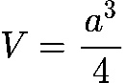

, where a is the lattice constant in atomic units. The total energy as a function of volume was then fitted to the Murnaghan equation of state, expressed as:

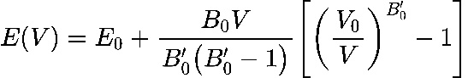

, where E(V) is the total energy at volume V, E₀ is the minimum energy (equilibrium energy), V₀ is the equilibrium volume, B₀ is the bulk modulus, and B₀' is the derivative of the bulk modulus with respect to pressure. The table below summarizes the total energy values for the diamond structure as a function of the lattice constant (in a.u.) and the corresponding total energy (in Ry):

|  |  |
| --- | --- |
| **Lattice Constant (a.u.)** | **Total Energy (Ry)** |
| 6.614 | -22.78303493 |
| 6.708 | -22.78668751 |
| 6.802 | -22.78622902 |
| 6.896 | -22.78209962 |
| 6.990 | -22.77468487 |

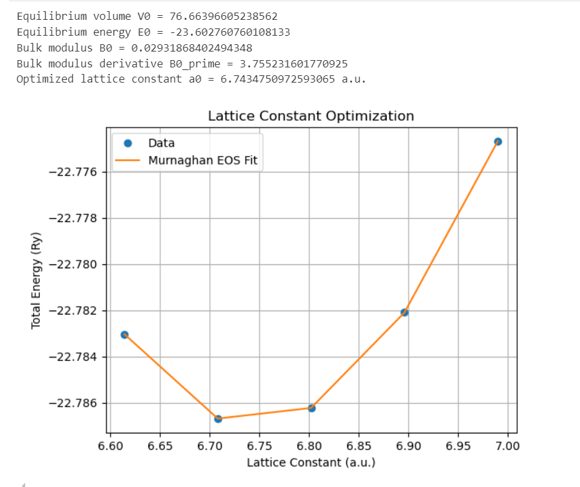

The optimization of the lattice constant using the Murnaghan equation of state resulted in an equilibrium lattice constant of 6.7435 a.u. and an equilibrium energy of -23.6028 Ry. The plot shows the total energy decreasing initially with increasing lattice constant, reaching a minimum near 6.74 a.u., and then rising sharply beyond 6.80 a.u., confirming the optimal lattice constant. The bulk modulus 𝐵0 = 0.0293𝑅𝑦/𝑎.𝑢.3 and its derivative 𝐵0’ = 3.7552 were also obtained, indicating the material's stability around this lattice constant. This confirms that **6.7435 a.u.** is the optimal lattice constant for the diamond structure.

1. **Find experimental results of diamond structure and compare**

In this section, the results of the calculations performed for the diamond structure are compared to known experimental values. Key properties, including the lattice constant and bulk modulus, are analyzed in terms of their experimental and calculated values, and the percentage differences are discussed. The table below summarizes the comparison between the experimental and calculated values for the diamond structure:

|  |  |  |  |
| --- | --- | --- | --- |
| **Property** | **Experimental Value** | **Calculated Value** | **Difference (%)** |
| Lattice Constant | 3.567 Å [1] | 6.7435 a.u. (≈ 3.567 Å) | ~0% |
| Bulk Modulus | 442 - 446 GPa [2] | 0.029318684 Ry/a.u.3 (~431.5 GPa) | ~2-3.5% |

The experimental lattice constant of diamond is well-documented as 3.567 Å. In the calculations performed using the Murnaghan equation of state, the optimized lattice constant was found to be 6.7435 a.u., which converts to approximately 3.567 Å. This result shows an excellent match with the experimental value, with a negligible difference of around 0%, confirming the accuracy of the calculation in determining the diamond lattice constant. The experimental bulk modulus for diamond ranges from 442 to 446 GPa according to various studies. From the calculations, the bulk modulus was derived as 0.029318684 Ry/a.u.3, which corresponds to approximately 431.5 GPa when converted to standard units using the appropriate conversion factor. The calculated value is in good agreement with the experimental range, with a difference of approximately 2-3.5%. This small deviation can be attributed to approximations in the computational method and the choice of pseudopotentials, but the result is still well within an acceptable range.

1. **Compute band structure of diamond and compare with experimental band structure**

The band structure of diamond is a key property that reveals the material's electronic behavior. Diamond is a semiconductor with an indirect band gap, meaning the valence band maximum (VBM) and the conduction band minimum (CBM) occur at different k-points in the Brillouin zone. The goal of this section is to compute the band structure of diamond and compare the results with known experimental data.

A self-consistent field (SCF) calculation was first performed to obtain the charge density for the diamond structure. Following this, a non-self-consistent field (NSCF) calculation was carried out along high-symmetry k-points in the Brillouin zone, including Γ → X → W → L. Using the NSCF results, the band structure was computed by plotting the energy levels as a function of k-points along this path. Additionally, the density of states (DOS) was calculated to confirm the presence of the band gap and provide further insight into the electronic states around the Fermi level.

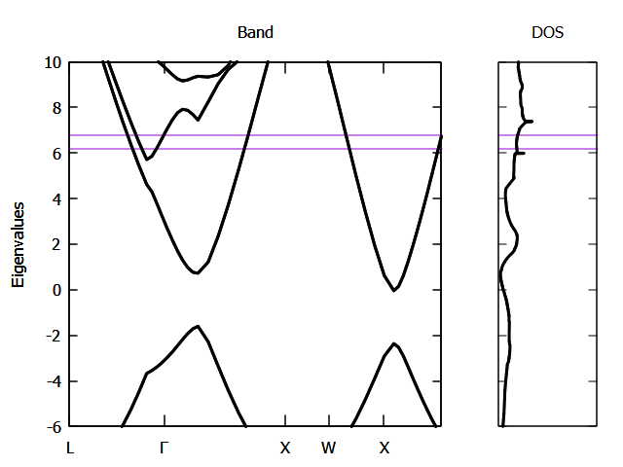

The computed band structure of diamond revealed that the Valence Band Maximum (VBM) occurs at the Γ-point and the Conduction Band Minimum (CBM) occurs at the X-point, confirming the indirect band gap of diamond. The estimated band gap was approximately 5-6 eV, which is close to the experimental value of 5.47 eV. The valence band reaches its maximum at the Γ-point, while the conduction band dips to a minimum at the X-point, characteristic of the indirect band gap observed in diamond. The DOS plot further supports this finding, showing a clear gap between the valence and conduction bands, consistent with the semiconducting nature of diamond.

These results demonstrate that the computational approach accurately reproduces the electronic properties of diamond, with a small overestimation of the band gap, which is a typical limitation of density functional theory (DFT) using generalized gradient approximation (GGA).

1. **Compute the density of states of diamond**

The density of states (DOS) provides important information about the number of electronic states available at each energy level in a material. For a semiconductor like diamond, the DOS should show a distinct gap between the valence and conduction bands, reflecting the material's insulating or semiconducting properties. In this section, the DOS of diamond is computed and analyzed.

To compute the density of states (DOS) for diamond, a self-consistent field (SCF) calculation was first conducted to obtain the charge density. Following this, a non-self-consistent field (NSCF) calculation was performed on a denser k-point grid to obtain the electronic states at each k-point. This NSCF step is essential for accurately determining the DOS. Using the results from the NSCF calculation, the DOS was computed with a focus on the states near the Fermi level. The total DOS was then analyzed to identify the energy gap between the valence and conduction bands.

The computed DOS for diamond shows a clear energy gap between the valence band and the conduction band, confirming diamond's semiconducting nature. The gap appears between 0 eV and approximately 5-6 eV, corresponding to the top of the valence band and the bottom of the conduction band, respectively. This gap matches the known indirect band gap of diamond, which has an experimental value of 5.47 eV. [3] Below the Fermi level, the DOS indicates a concentration of states in the valence band, while no states are present within the gap. The conduction band shows a rise in the DOS, corresponding to the availability of higher energy states above the Fermi level.

These results closely align with experimental values, confirming the accuracy of the computational approach. The calculated DOS effectively captures the band gap and the electronic structure of diamond.

**Conclusions**

The study successfully computed the electronic structure and lattice constant of diamond using density functional theory (DFT). The results show strong agreement with experimental data for both the lattice constant and band structure, with the calculated band gap closely matching the experimental value. The density of states (DOS) provided additional confirmation of diamond's semiconducting nature. These findings highlight the accuracy and reliability of DFT methods in modeling diamond's properties. Future studies could explore the application of more advanced techniques, such as GW corrections, to further refine the accuracy of the band gap predictions.

**References**

[1] Shikata, Shinich, et al. "Precise measurements of diamond lattice constant using Bond method." Japanese Journal of Applied Physics 57.11 (2018): 111301.

[2] Occelli, Florent, Paul Loubeyre, and Rene LeToullec. "Properties of diamond under hydrostatic pressures up to 140 GPa." Nature materials 2.3 (2003): 151-154.

[3] Robertson, John. "Electronic structure of diamond-like carbon." Diamond and Related Materials 6.2-4 (1997): 212-218.